**CS 200: Computer Organization**

**Project 5: Base64**

Shariq M. Jamil

Due: Friday, March 7, 2014

**Overview**

**Purpose**

This project required us to write a program in C or C++ that accepts a string and returns a Base64 encoding of the input.

**Approach**

In order to complete this project I decided to break the project into small sections and wrote pseudocode for each part. After that, I went through the sections and used Google heavily to convert each section of pseudocode to C code. The first step was to accept the string from the user followed by conversion to ASCII and then binary. This part was easier because we had created the function in the previous project. I used some web-searching and got pseudocode from some classmates that helped me come up with a method to convert sets of three bytes to four 6-bit integer sets. This was the hardest part of the project for me. All the other parts (breaking up the string, dealing with leftover characters and padding) came with intuition and researching more and more about how Base64 encoding works.

**Solution**

**Sample Output**

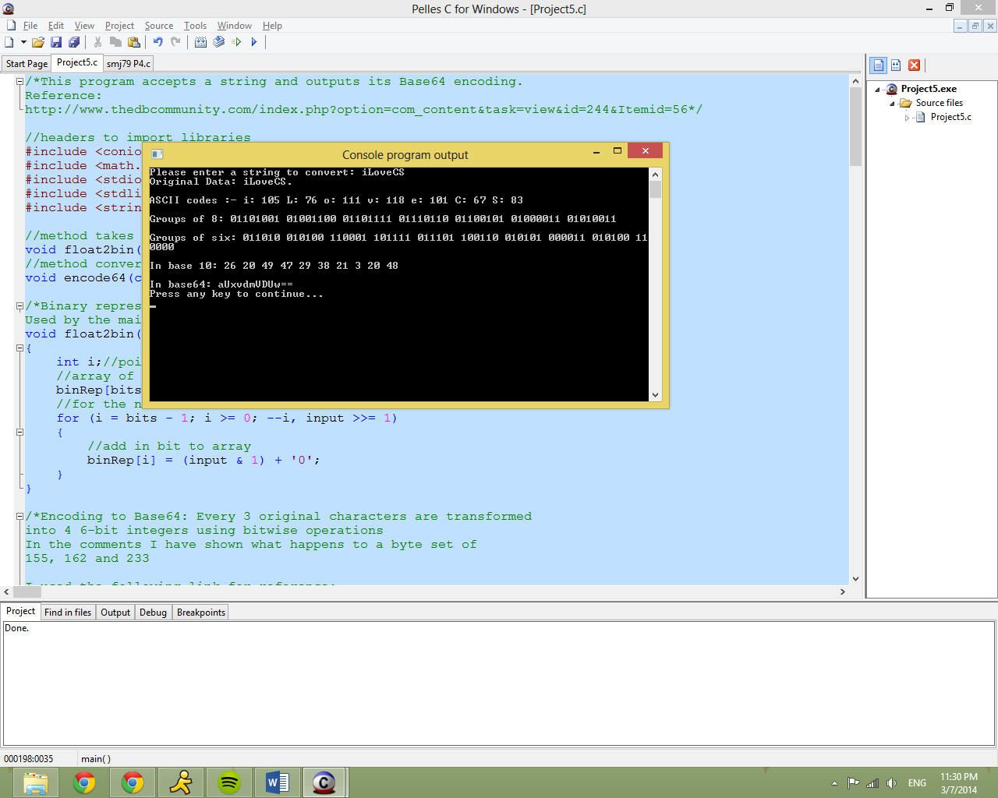

Figure 1: Sample Output

**Conclusion**

This project was very stressful for me because I had to deal with midterms for each CS class and could not start the project until today. I wish I had time to get the decoder started but it was not possible. This was the first time, I felt pushed to work with colleges in figuring out a solution due to time-constraints and it was a good exercise in working with others without depending too much on them or giving too much to them. This project was still a great experience in working with bitwise operators to create a more complex method to perform Base64 encoding. Once again, having a sample output in the project guide helped me come up with pseudocode easily. Without having the sample output, it would have been very difficult for me to provide the results this project required. Just like the previous project, this project pushed me to seek knowledge online. This project solidified binary representation knowledge. I feel like I can work on formulating different representation methods more intuitively having gone through with the past two projects.

**References**

BASE64 ENCODING

<http://www.thedbcommunity.com/index.php?option=com_content&task=view&id=244&Itemid=56>

How Base64 Encoding Works

http://email.about.com/cs/standards/a/base64_encoding.htm